Day 1: Data Analyst Role Overview
• Theory(1hr): Role,tools(Excel,SQL,Python,Tableau). Coursera: Data Analysis
• Practical (1 hr): Set up Python and Tableau, explore a dataset
Studied what a Data Analyst does:
- Collects data
- Cleans data
- Analyzes data
- Creates reports & dashboards
- Helps in decision-making
Understand why each tool is used:
- Excel: cleaning, pivot tables
- SQL: fetch data from databases
- Python: cleaning, analysis, statistics
- Tableau: dashboards & visualization
In practical : explored a dataset form Kaggle (Chocolate Sales)
In Vs Code:
Load Dataset in Python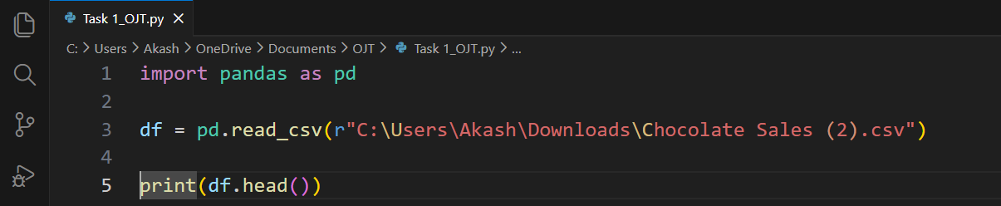
OUTPUT:
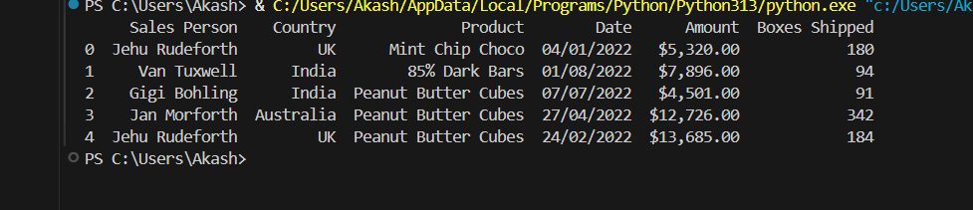

I used df.info() to understand the dataset structure and data types, and df.isnull().sum() to identify missing values that require cleaning
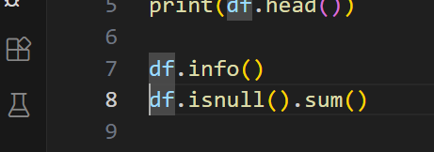
Result:
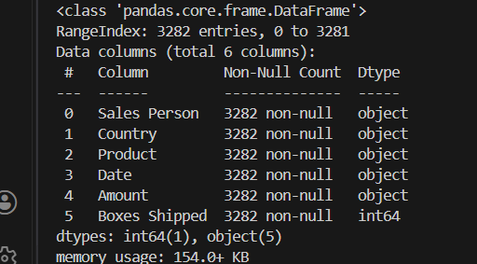

Next I moved to Tableau Public:
Opened new file and upload my dataset
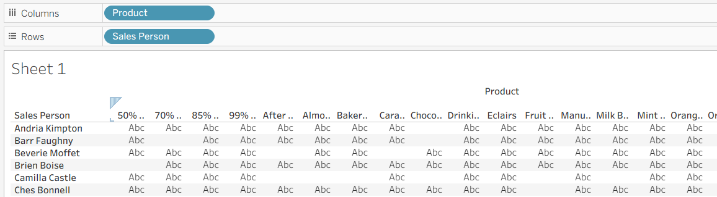
Conclusion:
Studied the Data Analyst role, responsibilities, and commonly used tools such as Excel, SQL, Python, and Tableau. Set up Python and Tableau Public environments and explored a sales dataset to understand data structure, columns, and basic data characteristics.
Day 2: SQL Basics
• Theory (1 hr): SELECT, JOIN, GROUP BY. W3Schools: SQL
• Practical (1 hr): Write SQL queries on a sample database (e.g., SQLite)
Installed MySQL and in MySQL editor
Created a database
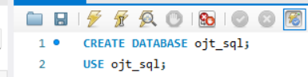
Created Customer table and order table
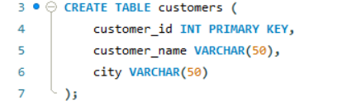
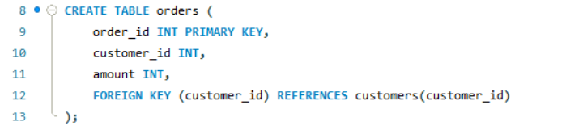

Now insert a Sample data
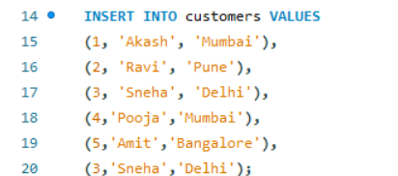

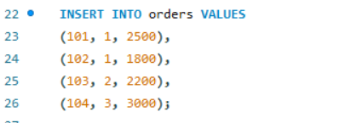

To view and explore data (SELECT Queries)

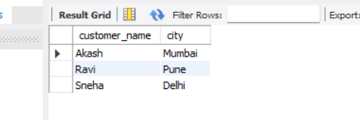
Filters records based on condition (WHERE Clause )
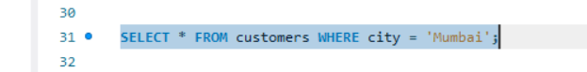
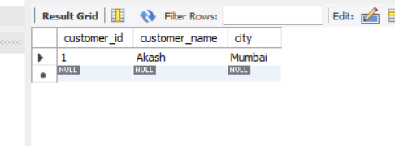

GROUP BY:
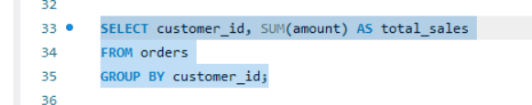
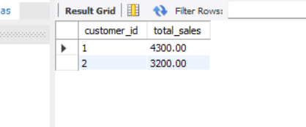

JOIN Query:
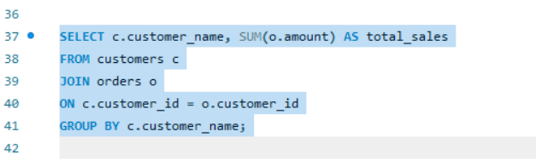

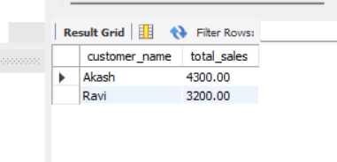
Conclusion:
I learned basic SQL concepts including SELECT, WHERE, GROUP BY, and JOIN. I created tables, inserted sample data, and executed queries to retrieve, filter, aggregate, and combine data for analysis using MySQL Workbench
Day 3: Data Cleaning with Python
• Theory (1 hr): Pandas for datacleaning, handling missing data. Pandas Documentation 1 Data Analyst Course Syllabus 2
• Practical (1 hr): Clean a dataset (e.g., remove duplicates) using pandas

USED GOOGLE COLAB for Cleaning the dataset using Pandas
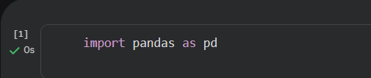

Load the Dataset (Chocolate Sales)
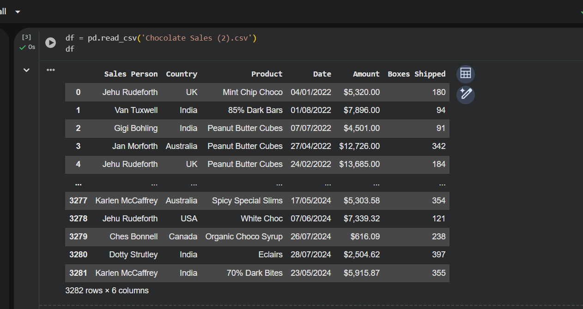

Cleaning the null values
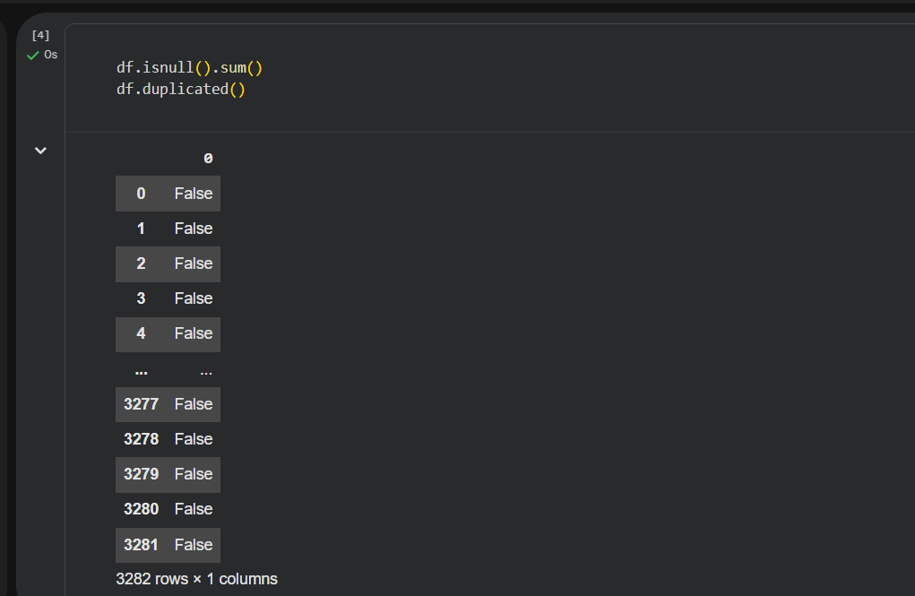

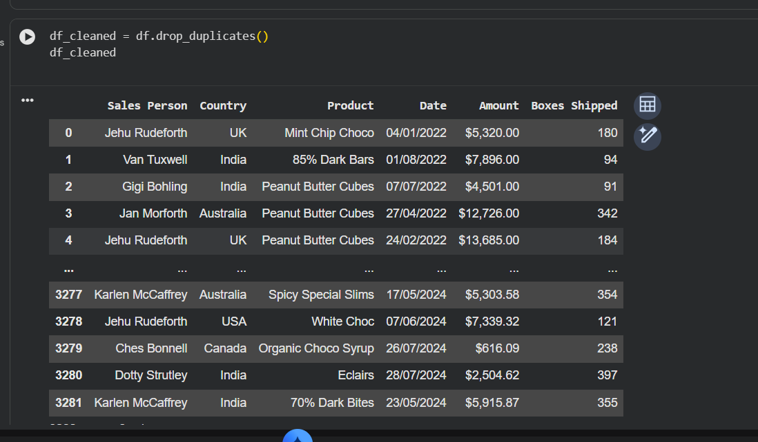

Day 4: Visualization with Tableau
• Theory(1hr): Tableaubasics, dashboardcreation. Tableau Learning
• Practical (1 hr): Create a dashboard in Tableau Public.

Installed Tableau in Desktop
- Opened new file and uploaded my dataset (Chocolate sales)
In sheet1 : Drag Product in Columns, Drag Sales in Rows ,and applied bar chart
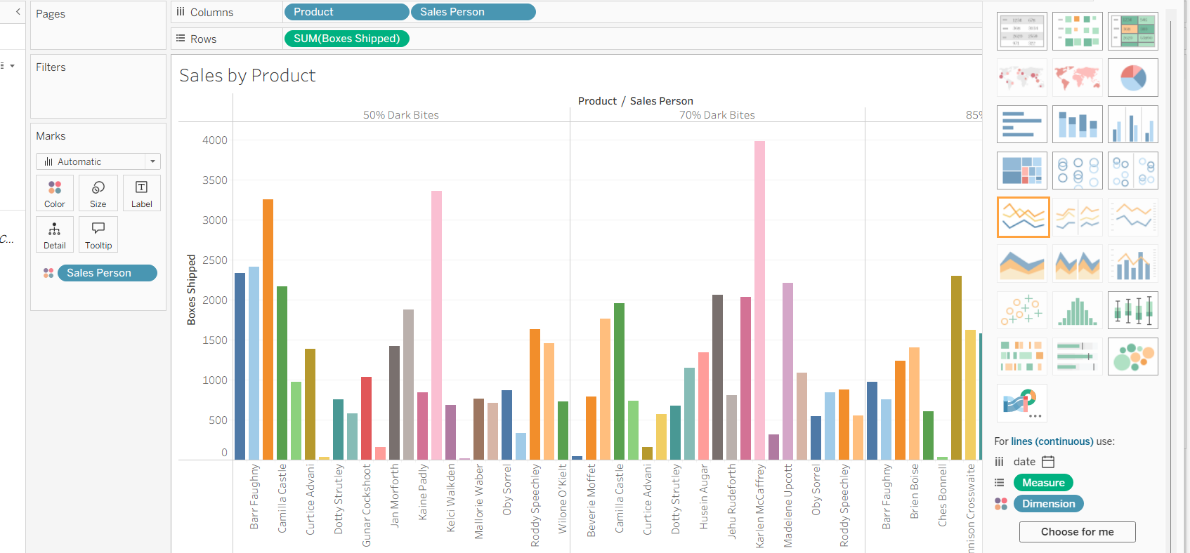
In sheet2 : Drag Region/country In Columns, Drag Sales In Rows, Applied Pie chart
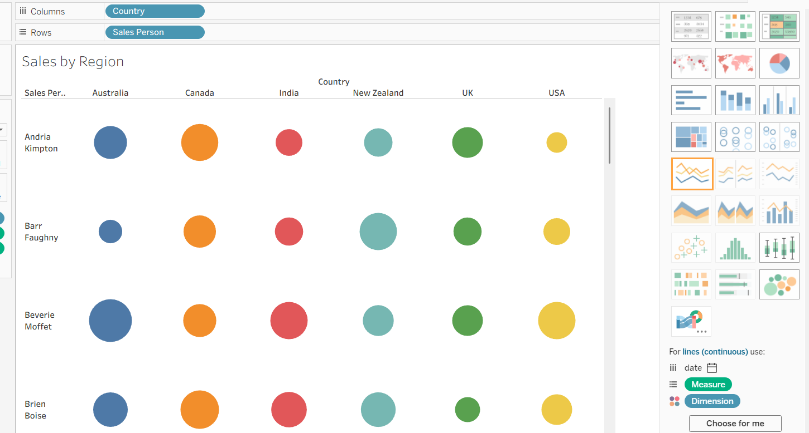

In sheet3 :
Drag date in column, Drag Sales in Rows , and applied Line chart
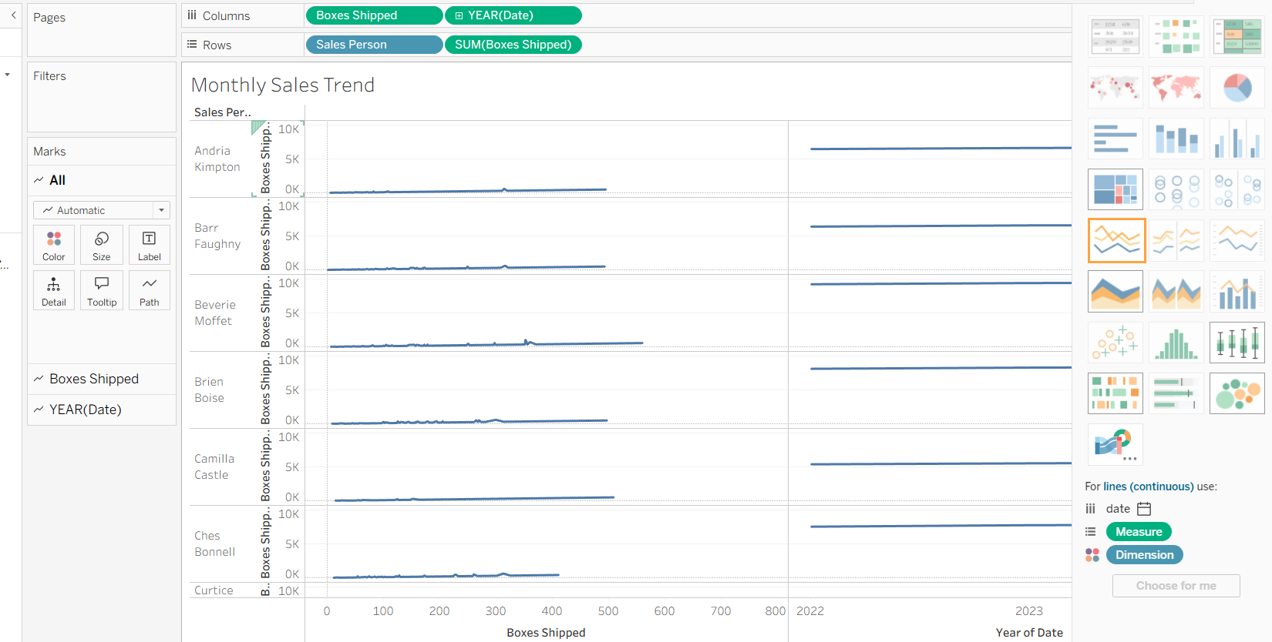
Now created a dashboard
- Dragged Sales by Product
- Sales by Region
- Monthly Sales Trend
And named title CHOCOLATE SALES DASHBOARD
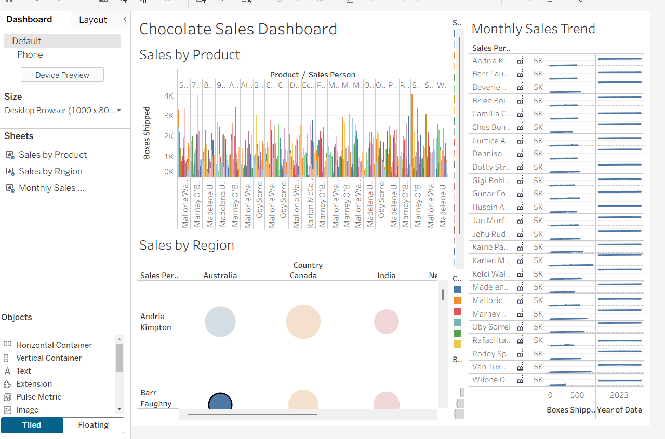
In conclusion:
I studied Tableau fundamentals and created an interactive dashboard in Tableau Public using a Chocolate Sales dataset. The dashboard includes product-wise sales, region-wise sales, and monthly sales trends to derive business insights

Day 5: Statistical Analysis
• Theory (1 hr): Descriptive statistics, hypothesis testing. Khan Academy: Statistics
• Practical (1 hr): Perform a t-test in Python using scipy.
import pandas and Read dataset
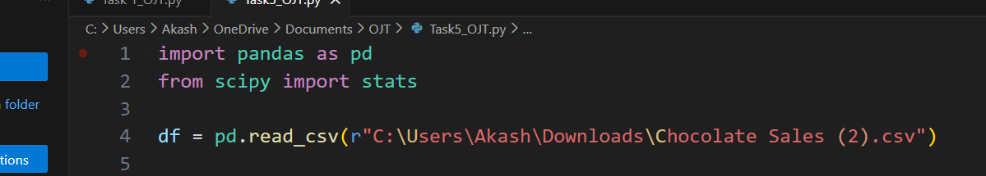
Amount column is being treated as text (string) so to fix this Convert Amount to numeric
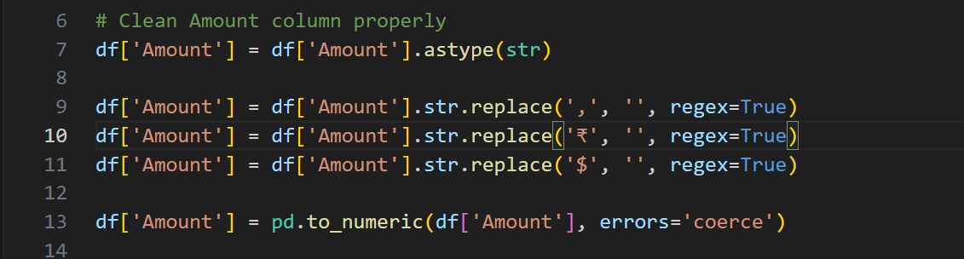
Then Now run the t-test
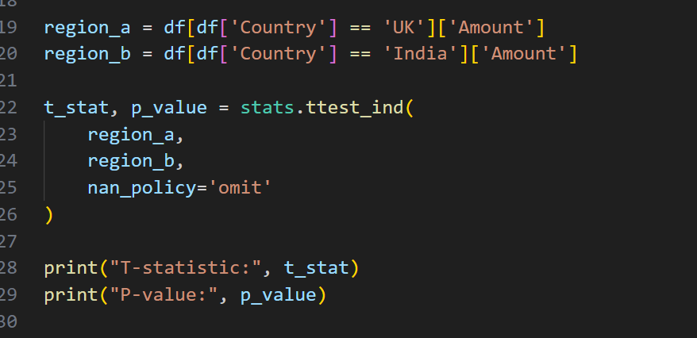

Conclusion:
I performed an independent t-test using Python to compare sales between two regions. Based on the p-value, I evaluated whether the difference in sales was statistically significant

• Theory (1 hr): A/B testing concepts, designing experiments. Coursera: A/B Testing
• Practical (1 hr): Simulate an A/B test in Python

